**User instructions**

After starting NEMESYS software user will see a window (Fig. 1)

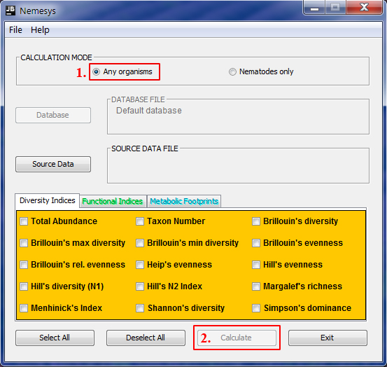

**Figure 1.**

1. By default the „Calculation mode“ is set to „Any organisms“ (1.) and the „Calculate“ button is disabled (2.)

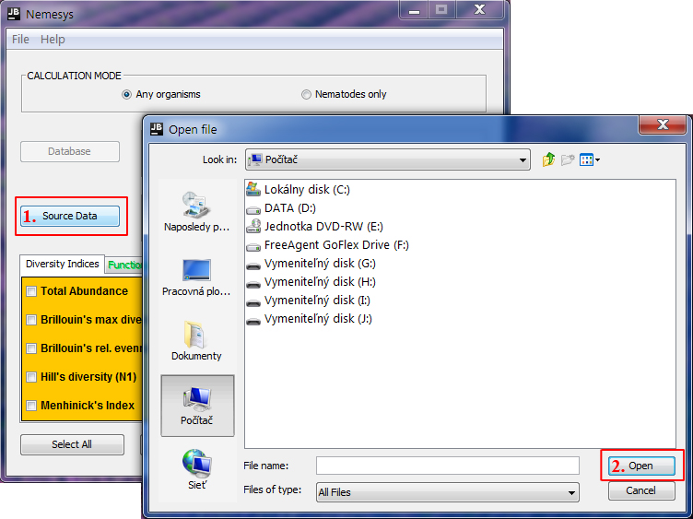

**Figure 2.**

1. For computing only diversity indices, the “Calculation mode” has to be set to “Any organisms” (Fig. 1), and user can upload the samples data sheet by clicking “Source Data” button (**1.**).
2. After clicking “Source Data” button a new window for choosing appropriate file will appeared (**2.**)

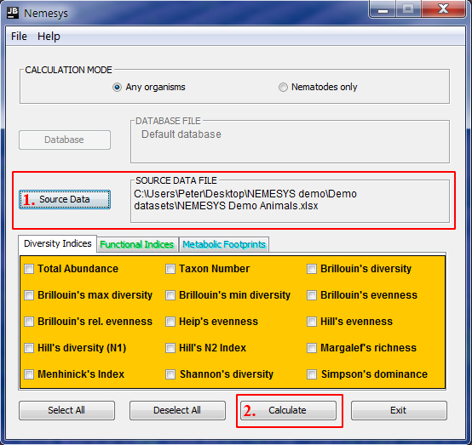

**Figure 3.**

1. After uploading file (Fig. 2) file pathway will appeared next to the “Source Data” button (**1.**)
2. The “Calculate” button is now enabled (**2.**)

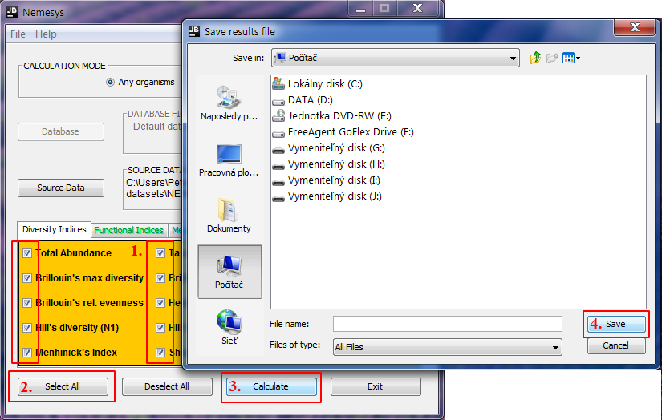

**Figure 4.**

1. User now can choose diversity indices (**1.**) under the “Diversity Indices” panel.
2. For easier manipulation user can use “Select All” and “Deselect All” buttons (**2.**).
3. By clicking “Calculate” button (**3.**), the computation of choose indices will begin.
4. When the computation finishes a new dialog window will appeared for saving results (**4.**)
5. User now can exit the program.

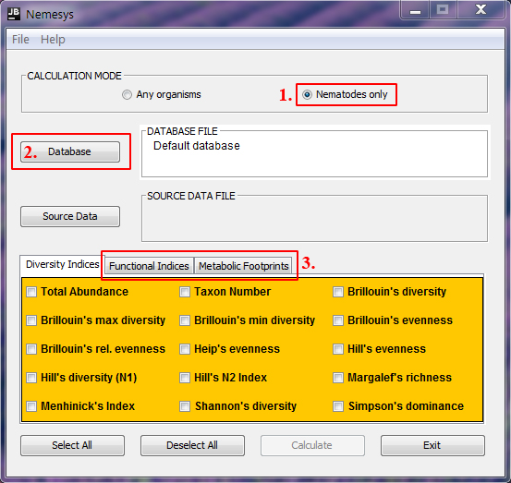

**Figure 5.**

1. In case user wants to calculate indices specific for nematodes, under “Calculation mode” choose “Nematodes only” option (**1.**)
2. Program will enabled “Database” button (**2.**) and “Functional Indices” and Metabolic Footprints” panels (**3.**)

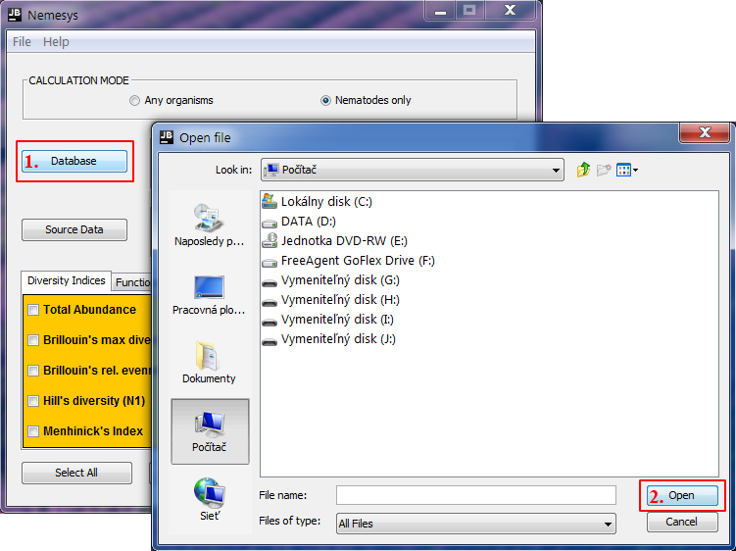

**Figure 6.**

1. Now user after clicking “Database” button (**1.**) can in new dialog window upload custom database for nematodes (**2.**)

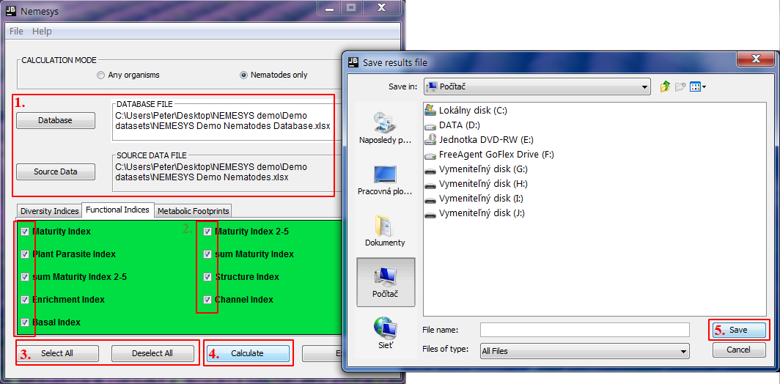

**Figure 7.**

1. After uploading custom database and sample data file (see Fig. 3), pathways of both files will be shown next to the buttons (**1.**)
2. Now user can choose indices (**2.**) on all three panels.
3. User can use “Select All” or “Deselect All” buttons for easier manipulation (**3.**).
4. The “Calculate” button is now enabled and after clicking it (**4.**), user can save results by using new saving dialog window (**5.**)
5. After saving results user can exit the program by clicking “exit” button.

**Errors in uploaded files (sample or database file)**

1. ***Database errors***

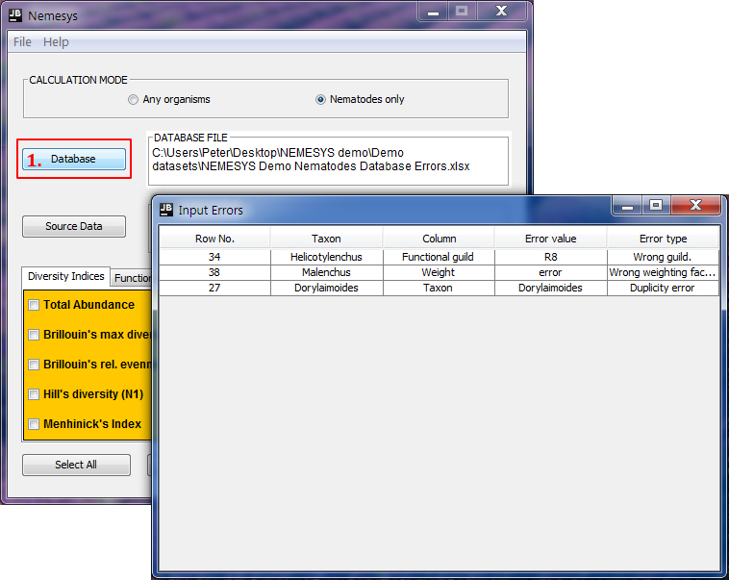

**Figure 8.**

1. NEMESYS is able to detected and warn user if there are errors within the uploaded database file. After uploading custom database (Fig. 6), program automatically check the file for inconsistency and errors (**1.**).
2. If program finds any errors it will displayed it in a new dialog window “Input Errors”, where exact location and type of the error in the uploaded file is described.
3. User has to correct the errors and upload the file again.
4. ***Sample data file errors***

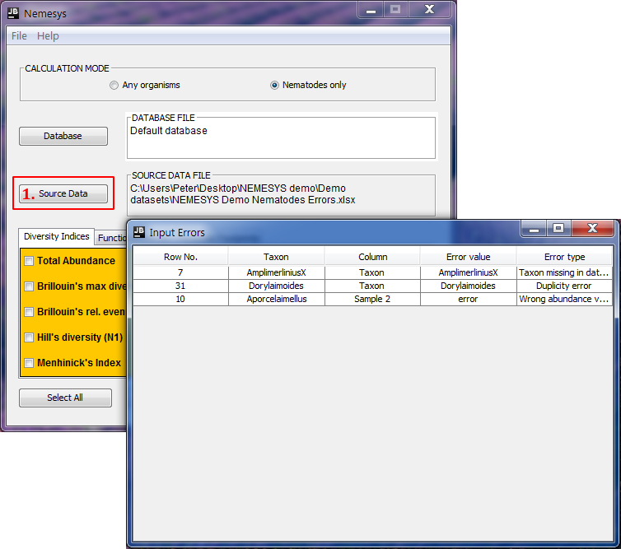

**Figure 9.**

1. NEMESYS is able to detected and warn user if there are errors within the uploaded sample data file. After uploading file (Fig. 6), program automatically check the file for inconsistency and errors (**1.**).
2. If program finds any errors it will displayed it in a new dialog window “Input Errors”, where exact location and type of the error in the uploaded file is described.
3. User has to correct the errors and upload the file again.

**Expected run time for demo files**

The expected run time for computation depends on two factors:

1. User speed – as NEMESYS depends on user how quickly is he able go through the computation procedure
2. The size of the sample data file

For the demo dataset the worse scenario – the user decided to calculate all indices for nematodes.

Uploading custom demo database and sample data demo file takes approximately 5 seconds each. The program is able to compute results approximately in 5 seconds. Therefore the complete program run from start to saving results could take approximately up to 30 seconds (additional 20 s for user responses). However the run could be longer as the total time of the run significantly depends on the user speed.

The demo run time was tested on PC with specifications 8 GB RAM, Intel(R) Core(TM) i5-4570 CPU @ 3.20GHz, Windows 7.